***Пералня система***

Съдържание:

Ардуино системата съдържа стандартни фукнции за пералня. Моторът задвижва барабана с различна скорост, в зависимост от подадената програма. Пералнята известителни светлини за клапан(1), помпа(2), нагревател(3) и за заключването на вратата(4).

Описание:

Потребителят на пералнята може да избере набор от 16 програми, всяка с различни цели.

Някои от програмите са “Вълна”, “Спорт”, “Стандартна” и др. След избране на програмата и зареждане на пералнята с дрехи, потребителя може да заключи вратата, която няма да се отвори до завършване на зададената му програма. Схемата има филтър на постояннотоковия мотор, който служи за изчистване на сигнала, и диод на релето, което го предпазва от изгаряне. Всичко се контролира от главен ON/OFF switch.

Блокова схема:

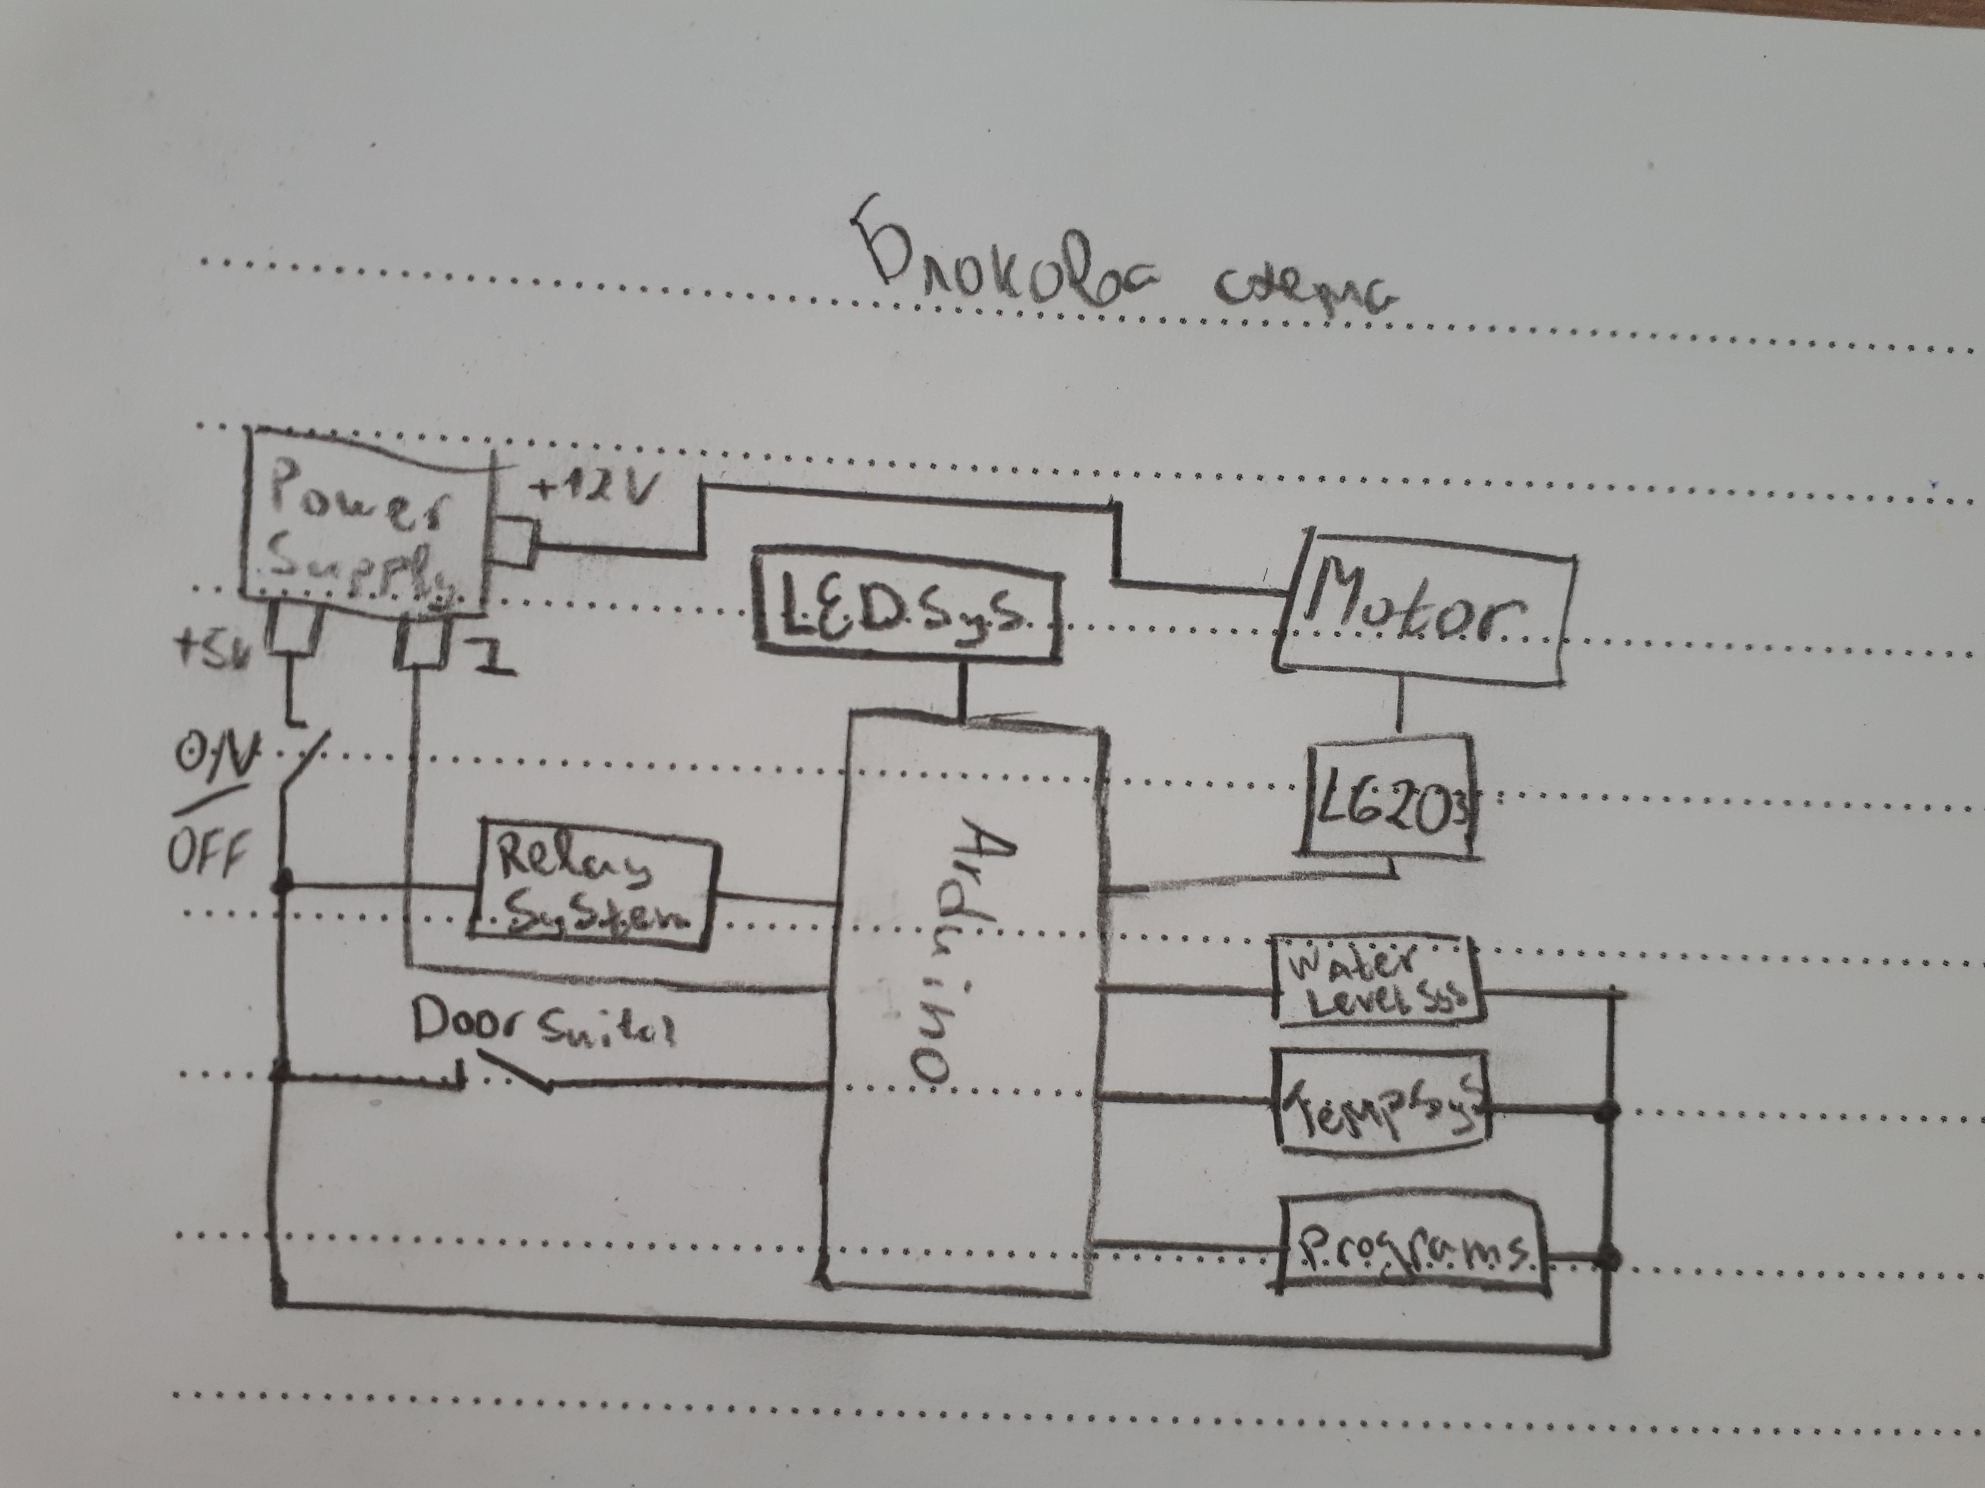

Електрическа схема:

Списък съставни части:

- DC Motor – 12V

- ИС - L6203

- R1-4 & R10-18 – 1 kΩ

- C1 – 100mF

- C2-7 – 100nF

- 3 Water Level Sensors – Replaced by manually controlled switches

- 3 Heat Level Sensors – Replaced by manually controlled switches

- 1 Stepping Potentiometer – 1-F

- Switch – “Door Switch”

- Arduino – Arduino Nano (ATMega256(Old Bootloader))

- DC Motor Controller – Manually crafted

Source Code:

‘’’C

//Water Storage Levels

#define EMPTY_WATER 1

#define HALF_FILLED_WATER 2

#define FULLY_FILLED_WATER 3

//Heater Pins

#define LIGHTLY_HEATED_WATER 1

#define MEDIUMLY_HEATED_WATER 2

#define HEAVILY_HEATED_WATER 3

//Motor Pins

#define MOTOR_F_R 12

#define MOTOR_PWM 10

//Water Level Pins

#define WATER_LEVEL_2 9

#define WATER_LEVEL_1 8

#define WATER_LEVEL_EMP 7

//Tempreture Level Pins

#define TEMP_LEVEL_HIGH 6

#define TEMP_LEVEL_MED 5

#define TEMP_LEVEL_LOW 4

//Program Selection Pins

#define PROG_SELECT_4 3

#define PROG_SELECT_3 2

#define PROG_SELECT_2 1

#define PROG_SELECT_1 0

//Outputs

#define WATER_VALVE A0

#define WATER_PUMP A1

#define WATER_HEATER A2

#define LOCK_DOOR A3

//Relay Pin

#define RELAY A4

//Global And Default Variables

#define DEFAULT_MOTOR_CYCLES 100

#define MAX_MOTOR_SPEED 255

#define MEDIUM_MOTOR_SPEED 128

#define LOW_MOTOR_SPEED 50

//Methods Declaration

void DefineIO();

void PowerOnRelay();

void LockDoor();

void UnlockDoor();

void FulfillProgram(byte selectedProgram);

byte ReadProgram();

void FillWater(byte level);

bool ReadWaterLevel(byte level);

void HeatWater(byte level);

bool ReadHeatLevel(byte level);

void SpinMotor(unsigned int cycles, byte speed);

void Wash(unsigned int cycles, byte speed);

void Centrifuge(unsigned int cycles, byte speed);

void TurnPumpON();

void TurnPumpOFF();

//First you need to select a program from 1-F

//Initialize all startup vars

void setup()

{

//Select which ports does what

DefineIO();

//Turn on the Realy to read the inputs from the sensors

PowerOnRelay();

delay(1000);

//Lock the "door"

LockDoor();

//Read the selected program from the user

byte selectedProgram = ReadProgram();

FulfillProgram(selectedProgram);

UnlockDoor();

delay(5000);

}

void loop() {}

void DefineIO()

{

//Motor(OUTPUT):

// D12 - F/R

// D10 - PWM

pinMode(MOTOR_F_R, OUTPUT);

pinMode(MOTOR_PWM, OUTPUT);

//Water Level System(INPUT):

// D9 - WL2

// D8 - WL1

// D7 - WL_EMPTY

pinMode(WATER_LEVEL_2, INPUT);

pinMode(WATER_LEVEL_1, INPUT);

pinMode(WATER_LEVEL_EMP, INPUT);

//Tempreture Level System(INPUT):

// D6 - TL_HIGH

// D5 - TL_MED

// D4 - TL_LOW

pinMode(TEMP_LEVEL_HIGH, INPUT);

pinMode(TEMP_LEVEL_MED, INPUT);

pinMode(TEMP_LEVEL_LOW, INPUT);

//Program Selection(INPUT):

// D3 - PS4

// D2 - PS3

// RX - PS2

// TX - PS1

pinMode(PROG_SELECT_1, INPUT);

pinMode(PROG_SELECT_2, INPUT);

pinMode(PROG_SELECT_3, INPUT);

pinMode(PROG_SELECT_4, INPUT);

//Outputs

pinMode(WATER_VALVE, OUTPUT);

pinMode(WATER_PUMP, OUTPUT);

pinMode(WATER_HEATER, OUTPUT);

pinMode(LOCK_DOOR, OUTPUT);

pinMode(RELAY, OUTPUT);

}

void PowerOnRelay()

{

digitalWrite(RELAY, HIGH);

}

void LockDoor()

{

digitalWrite(LOCK_DOOR, HIGH);

}

void UnlockDoor()

{

digitalWrite(LOCK_DOOR, LOW);

}

byte ReadProgram()

{

//Table of truth:

// PS1|PS2|PS3|PS4|PG Num

// 0 | 0 | 0 | 0 | P0

// 0 | 0 | 0 | 1 | P1

// 0 | 0 | 1 | 0 | P2

// 0 | 0 | 1 | 1 | P3

// 0 | 1 | 0 | 0 | P4

// 0 | 1 | 0 | 1 | P5

// 0 | 1 | 1 | 0 | P6

// 0 | 1 | 1 | 1 | P7

// 1 | 0 | 0 | 0 | P8

// 1 | 0 | 0 | 1 | P9

// 1 | 0 | 1 | 0 | P10

// 1 | 0 | 1 | 1 | P11

// 1 | 1 | 0 | 0 | P12

// 1 | 1 | 0 | 1 | P13

// 1 | 1 | 1 | 0 | P14

// 1 | 1 | 1 | 1 | P15

int PS4 = digitalRead(PROG_SELECT_4); //0

int PS3 = digitalRead(PROG_SELECT_3); //0

int PS2 = digitalRead(PROG_SELECT_2); //0

int PS1 = digitalRead(PROG_SELECT_1); //1

if(PS4 == 0 && PS3 == 0 && PS2 == 0 && PS1 == 0) return 0;

if(PS4 == 0 && PS3 == 0 && PS2 == 0 && PS1 == 1) return 1;

if(PS4 == 0 && PS3 == 0 && PS2 == 1 && PS1 == 0) return 2;

if(PS4 == 0 && PS3 == 0 && PS2 == 1 && PS1 == 1) return 3;

if(PS4 == 0 && PS3 == 1 && PS2 == 0 && PS1 == 0) return 4;

if(PS4 == 0 && PS3 == 1 && PS2 == 0 && PS1 == 1) return 5;

if(PS4 == 0 && PS3 == 1 && PS2 == 1 && PS1 == 0) return 6;

if(PS4 == 0 && PS3 == 1 && PS2 == 1 && PS1 == 1) return 7;

if(PS4 == 1 && PS3 == 0 && PS2 == 0 && PS1 == 0) return 8;

if(PS4 == 1 && PS3 == 0 && PS2 == 0 && PS1 == 1) return 9;

if(PS4 == 1 && PS3 == 0 && PS2 == 1 && PS1 == 0) return 10;

if(PS4 == 1 && PS3 == 0 && PS2 == 1 && PS1 == 1) return 11;

if(PS4 == 1 && PS3 == 1 && PS2 == 0 && PS1 == 0) return 12;

if(PS4 == 1 && PS3 == 1 && PS2 == 0 && PS1 == 1) return 13;

if(PS4 == 1 && PS3 == 1 && PS2 == 1 && PS1 == 0) return 14;

if(PS4 == 1 && PS3 == 1 && PS2 == 1 && PS1 == 1) return 15;

else return 0;

}

void FulfillProgram(byte selectedProgram)

{

switch (selectedProgram)

{

//Standard washing program

case 1:

{

FillWater(HALF_FILLED_WATER);

HeatWater(MEDIUMLY_HEATED_WATER);

Wash(DEFAULT_MOTOR_CYCLES, 50);

Centrifuge(DEFAULT_MOTOR_CYCLES, 50);

break;

}

//Just Centrifuge

case 2:

{

Centrifuge(100, MAX_MOTOR_SPEED);

break;

}

//Quick Program

case 3:

{

FillWater(HALF_FILLED_WATER);

Wash(DEFAULT_MOTOR_CYCLES, MAX_MOTOR_SPEED);

delay(1500);

Centrifuge(DEFAULT_MOTOR_CYCLES, MAX_MOTOR_SPEED);

break;

}

//Double Washing

case 4:

{

FillWater(FULLY_FILLED_WATER);

HeatWater(MEDIUMLY_HEATED_WATER);

delay(1000);

Wash(100, MEDIUM_MOTOR_SPEED);

Centrifuge(100, MEDIUM_MOTOR_SPEED);

delay(5000);

FillWater(HALF_FILLED_WATER);

delay(1000);

Wash(100, MEDIUM_MOTOR_SPEED);

Centrifuge(100, MEDIUM_MOTOR_SPEED);

TurnPumpON();

delay(2000);

TurnPumpOFF();

break;

}

//Gental Spin

case 5:

{

FillWater(HALF_FILLED_WATER);

Wash(20, LOW_MOTOR_SPEED);

delay(2000);

Centrifuge(20, LOW_MOTOR_SPEED);

break;

}

//Wool

case 6:

{

FillWater(FULLY_FILLED_WATER);

delay(1500);

Wash(100, MAX_MOTOR_SPEED);

Centrifuge(250, MAX_MOTOR_SPEED);

break;

}

//Sport Wash

case 7:

{

FillWater(FULLY_FILLED_WATER);

Wash(250, MAX_MOTOR_SPEED);

TurnPumpON();

delay(10000);

TurnPumpOFF();

}

default:

{

//If P0 is selected:

// Wait for user to reselect a prorgam and then read it

}

}

void FillWater(byte level)

{

//Power on LED

digitalWrite(WATER_VALVE, HIGH);

delay(2000);

while (1)

{

//HALF_FILLED

bool filled = ReadWaterLevel(level);

if (filled == true)

{

digitalWrite(WATER_VALVE, LOW);

break;

}

}

}

bool ReadWaterLevel(byte level)

{

int waterLevel = 0;

//HALF_FILLED

if (level == EMPTY_WATER)

waterLevel = digitalRead(WATER_LEVEL_EMP);

else if (level == HALF_FILLED_WATER)

waterLevel = digitalRead(WATER_LEVEL_1);

else if (level == FULLY_FILLED_WATER)

waterLevel = digitalRead(WATER_LEVEL_2);

return waterLevel == 1

? true : false;

}

void HeatWater(byte level)

{

digitalWrite(WATER_HEATER, HIGH);

while (1)

{

//mediumly

bool heated = ReadHeatLevel(level);

if (heated == true)

{

digitalWrite(WATER_HEATER, LOW);

break;

}

}

}

bool ReadHeatLevel(byte level)

{

int heatLevel = 0;

if (level == LIGHTLY_HEATED_WATER)

heatLevel = digitalRead(TEMP_LEVEL_LOW);

else if (level == MEDIUMLY_HEATED_WATER)

heatLevel = digitalRead(TEMP_LEVEL_MED);

else if (level == HEAVILY_HEATED_WATER)

heatLevel = digitalRead(TEMP_LEVEL_HIGH);

return heatLevel == 1

? true : false;

}

void SpinMotor(unsigned int cycles, byte speed)

{

for (byte i = 0; i < cycles; i++)

{

//Spin forward

digitalWrite(MOTOR_F_R, HIGH); //Select Forward

analogWrite(MOTOR_PWM, speed); //Define Speed

}

delay(100);

for (byte i = 0; i < cycles; i++)

{

//Spin backwards

digitalWrite(MOTOR_F_R, LOW ); //Select Backwards

analogWrite(MOTOR_PWM, speed); //Define Speed

}

//Turn off motor

analogWrite(MOTOR_PWM, 0);

}

void Wash(unsigned int cycles, byte speed)

{

SpinMotor(cycles, speed);

}

void Centrifuge(unsigned int cycles, byte speed)

{

TurnPumpON();

SpinMotor(cycles, speed);

TurnPumpOFF();

}

void TurnPumpON()

{

digitalWrite(WATER_PUMP, HIGH);

}

void TurnPumpOFF()

{

digitalWrite(WATER_PUMP, LOW);

}// Start washing with the selected program

delay(5000);

selectedProgram = ReadProgram();

}

}

}

void FillWater(byte level)

{

//Power on LED

digitalWrite(WATER_VALVE, HIGH);

delay(2000);

while (1)

{

//HALF_FILLED

bool filled = ReadWaterLevel(level);

if (filled == true)

{

digitalWrite(WATER_VALVE, LOW);

break;

}

}

}

bool ReadWaterLevel(byte level)

{

int waterLevel = 0;

//HALF_FILLED

if (level == EMPTY_WATER)

waterLevel = digitalRead(WATER_LEVEL_EMP);

else if (level == HALF_FILLED_WATER)

waterLevel = digitalRead(WATER_LEVEL_1);

else if (level == FULLY_FILLED_WATER)

waterLevel = digitalRead(WATER_LEVEL_2);

return waterLevel == 1

? true : false;

}

void HeatWater(byte level)

{

digitalWrite(WATER_HEATER, HIGH);

while (1)

{

//mediumly

bool heated = ReadHeatLevel(level);

if (heated == true)

{

digitalWrite(WATER_HEATER, LOW);

break;

}

}

}

bool ReadHeatLevel(byte level)

{

int heatLevel = 0;

if (level == LIGHTLY_HEATED_WATER)

heatLevel = digitalRead(TEMP_LEVEL_LOW);

else if (level == MEDIUMLY_HEATED_WATER)

heatLevel = digitalRead(TEMP_LEVEL_MED);

else if (level == HEAVILY_HEATED_WATER)

heatLevel = digitalRead(TEMP_LEVEL_HIGH);

return heatLevel == 1

? true : false;

}

void SpinMotor(unsigned int cycles, byte speed)

{

for (byte i = 0; i < cycles; i++)

{

//Spin forward

digitalWrite(MOTOR_F_R, HIGH); //Select Forward

analogWrite(MOTOR_PWM, speed); //Define Speed

}

delay(100);

for (byte i = 0; i < cycles; i++)

{

//Spin backwards

digitalWrite(MOTOR_F_R, LOW ); //Select Backwards

analogWrite(MOTOR_PWM, speed); //Define Speed

}

//Turn off motor

analogWrite(MOTOR_PWM, 0);

}

void Wash(unsigned int cycles, byte speed)

{

SpinMotor(cycles, speed);

}

void Centrifuge(unsigned int cycles, byte speed)

{

TurnPumpON();

SpinMotor(cycles, speed);

TurnPumpOFF();

}

void TurnPumpON()

{

digitalWrite(WATER_PUMP, HIGH);

}

void TurnPumpOFF()

{

digitalWrite(WATER_PUMP, LOW);

}

‘’’

Заключение:

Пералнята може да бъде подобрена при интеграция с тяло и помяна на потенциометъра за избиране на програмите. Схемата е компактна и модуларна, позволявайки за разширение на функционалностите в бъдеще. На този етап сензорите се контролират директно, но при перфектни условия ще бъдат задействани от реални действия като нивото на вода и температурата и.